December 2018 Events
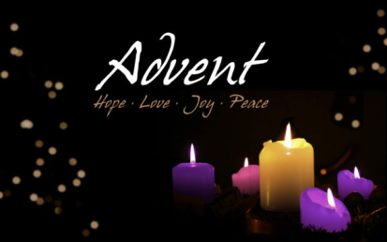
Advent Bible Study
“Christmas Gifts That Won’t Break” by James W. Moore
Sunday 1:30 p.m.
Wednesday 10:00 a.m.

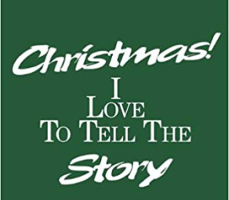
Christmas Cantata “I Love to Tell the Story”
Sunday December 9
10:15 a.m.
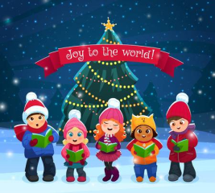
Christmas Caroling
Sunday December 9
2:00 p.m.

American Baptist Women’s Ministries
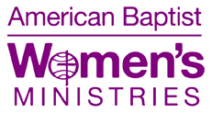
December 20, 2018
1:15 p.m.
Program – White Elephant Auction

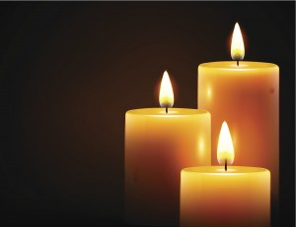
Candlelight Worship Service
Sunday, December 23, 2018
10:15 a.m.

Weekly Men’s Breakfast
Wednesday 8:00 a.m.
McDonald’s

Bruce, these images are just suggestions. Please feel free to use others you may find.

